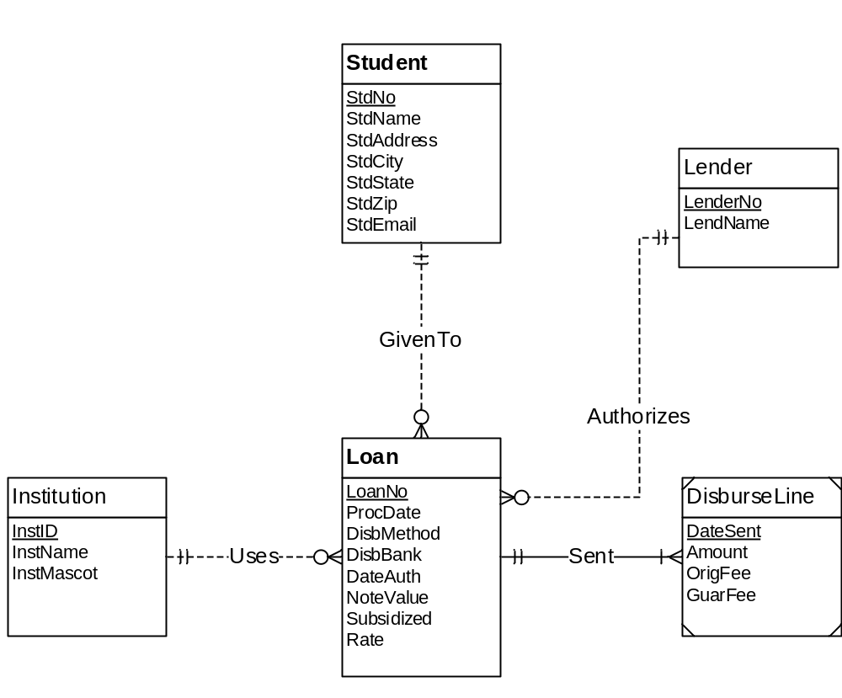
Figure 1: ERD for Problems 1 to 4
- Student ( PRIMARY KEY(StdNo),StdName,StdAddress,StdCity,StdState,StdZip,StdEmail)
- Lender ( PRIMARY KEY(LenderNo),LendName)
- Institution ( PRIMARY KEY(InstID),InstName,InstMascot)
- Loan ( PRIMARY KEY (LoanNo) ,ProcDate,DisbMethod,DisbBank,DateAuth,NoteValue,Subsidized,Rate)

- DisburseLine ( PRIMARY KEY(DateSent),Amount,OrigFee,GuarFee)

